**Traffic Data scrape through image capture and processing**

**Description of work:**

I ‘d like help with scraping traffic data from google maps. The idea is to get the data by taking “screenshots” or saving the displayed map viewport as an image. Next the image needs to be processed to extract the traffic data associated with the coordinates on the map at those points (Lat, Lng). We should be able to do this based on calling the viewport to anchor to certain Lat, Lng.

**Return the data as:** (Lat, Lng, <traffic color>) with granularity determined by pixel-2-distance dimension (zoom)

*Lat, Lng have at least 5 decimal point places (000.00001) or

3.65 ft distance increments in latitude (south- 🡨 equator 🡪 north+) change

2.8 ft distance in longitude (west- 🡨 Greenwich 🡪 east+). (At Denver’s latitude which is ~39.5 to 40). Note that latitude steps are longer toward the equator since the earth is an oblate spheroid that bulges at the equator due to its spin (centrifugal force).

We would want to take the images at a zoomed in level so get the most granular data and this will require a more “stepping” over the map area we want to cover – Denver Metro area for now).

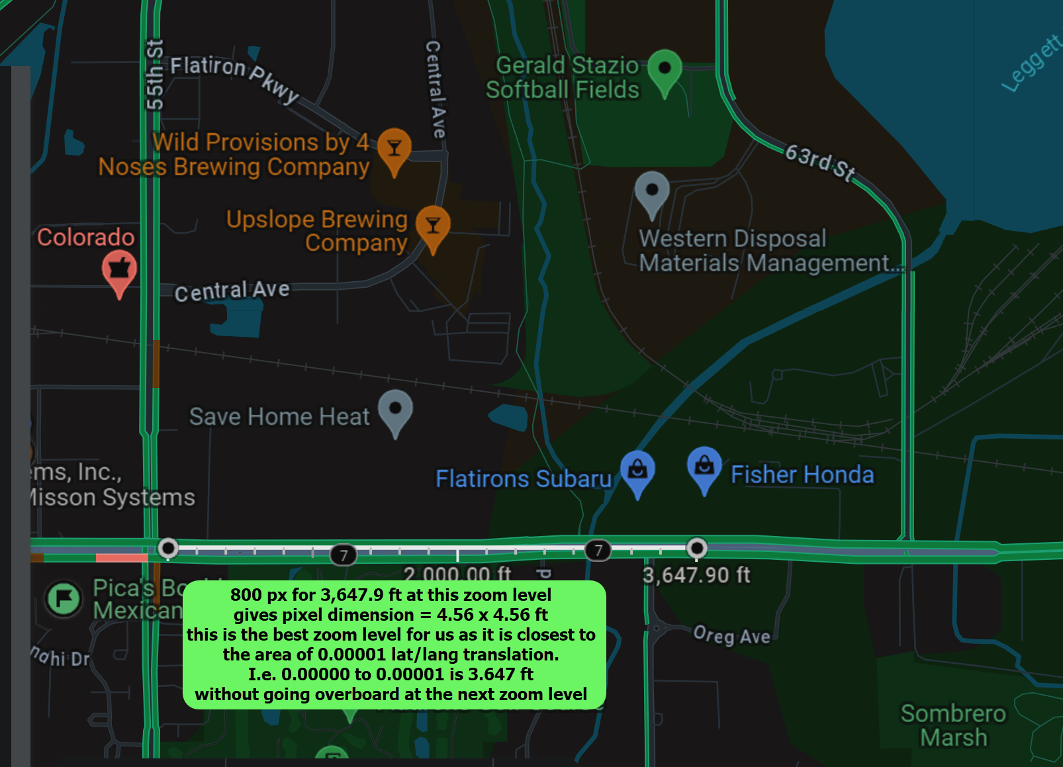

Requirements:

Manipulation of the google maps browser viewport and then capture of the viewport image.

Label Lat, Lng values to pixels based on known stepping distance through viewport area (image pixel dimensions) at the certain zoom level.

Image processing to extract traffic color from pixels/coordinates.

Robust for continuous use and set up to be undetectable by google (proxy network service if required).

Preferred language use: Python, Javascript, (maybe R)

Ref similar thing that may be considered to use or draw from:

<https://github.com/dime-worldbank/googletraffic>

OR use the TOM-TOM API or other good and cheap data source

<https://developer.tomtom.com/store/maps-api?source_app=b2b&source_product=traffic-apis>

39.885187, -105.052961

39.885166, -105.048582

0.052961- 0.048582

1213